**Practical Task 1:** Deploy a Docker Container to Azure Container Instances (ACI) via Azure Portal Requirements:

1. Create a lightweight Docker image for a simple web application (e.g., a Python Flask app) with minimal dependencies to reduce resource usage. 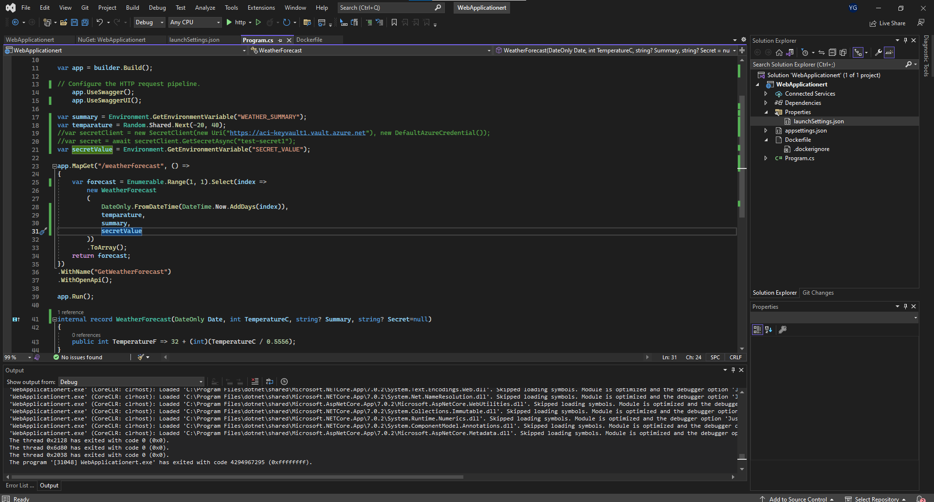

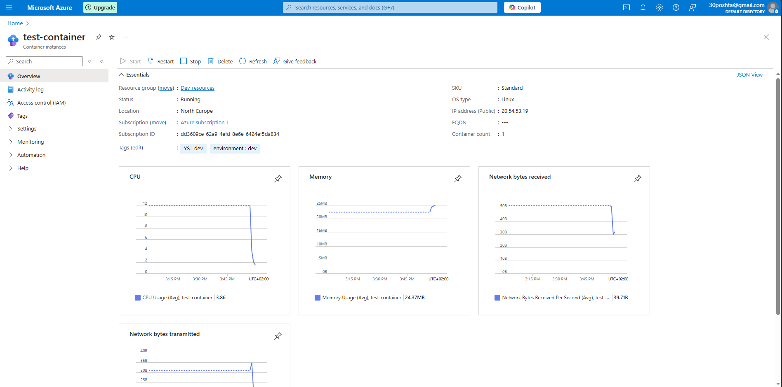

2. Push the Docker image to Azure Container Registry (ACR) using a low-cost storage option. 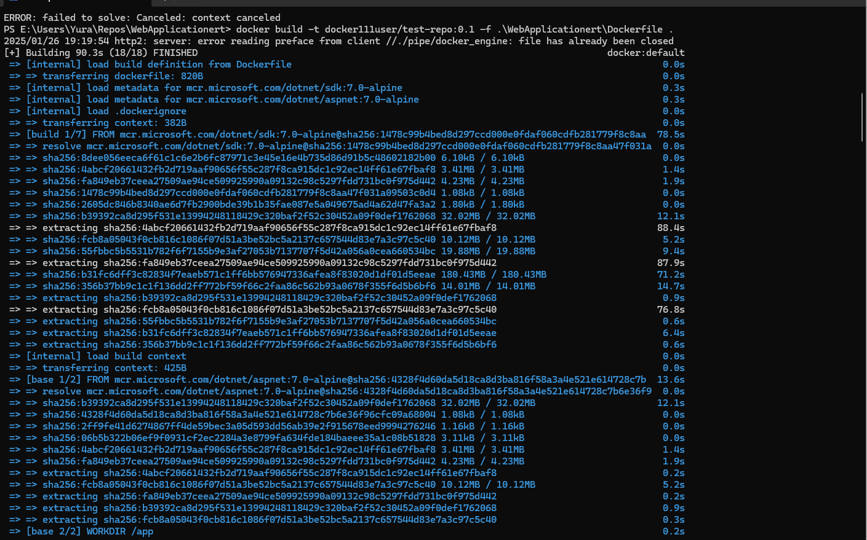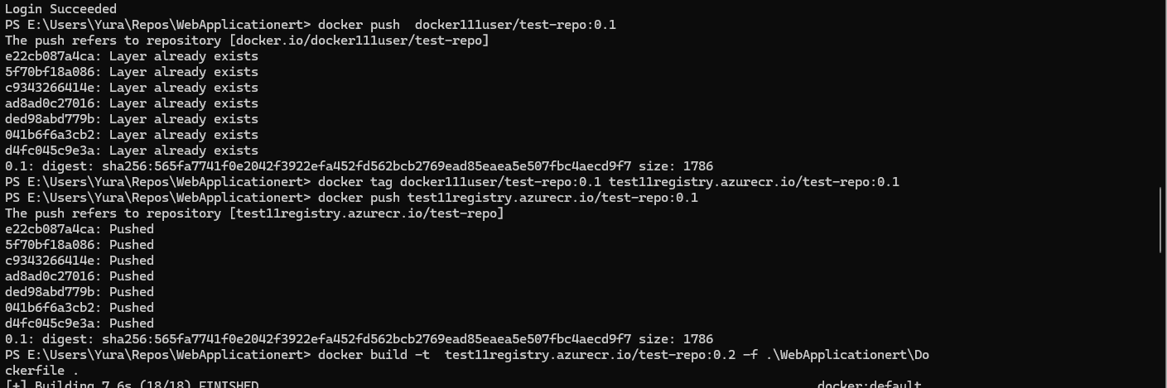

3. Use a lightweight ACI instance (e.g., B1s) to deploy the Docker container from ACR. 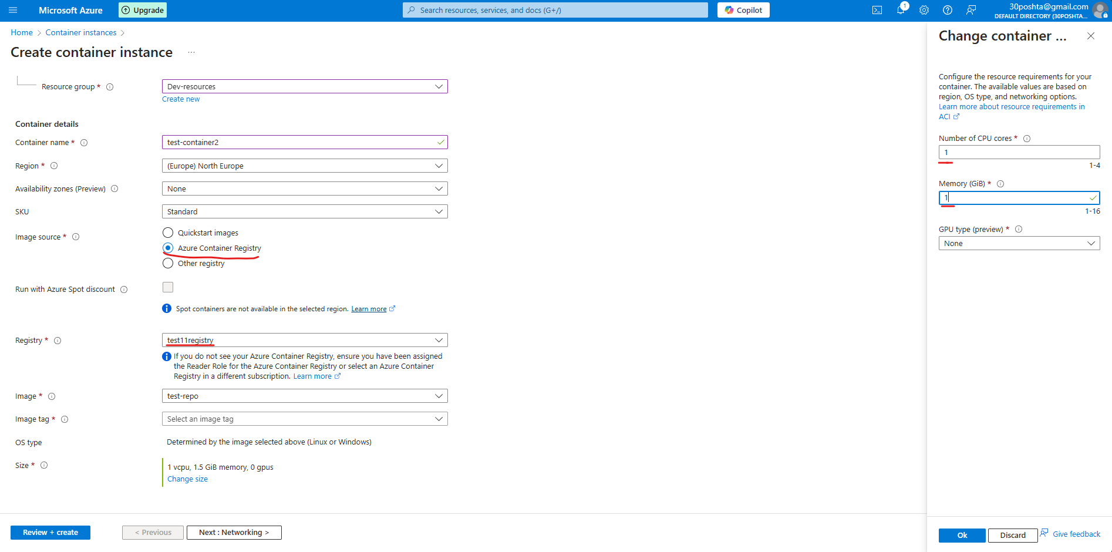 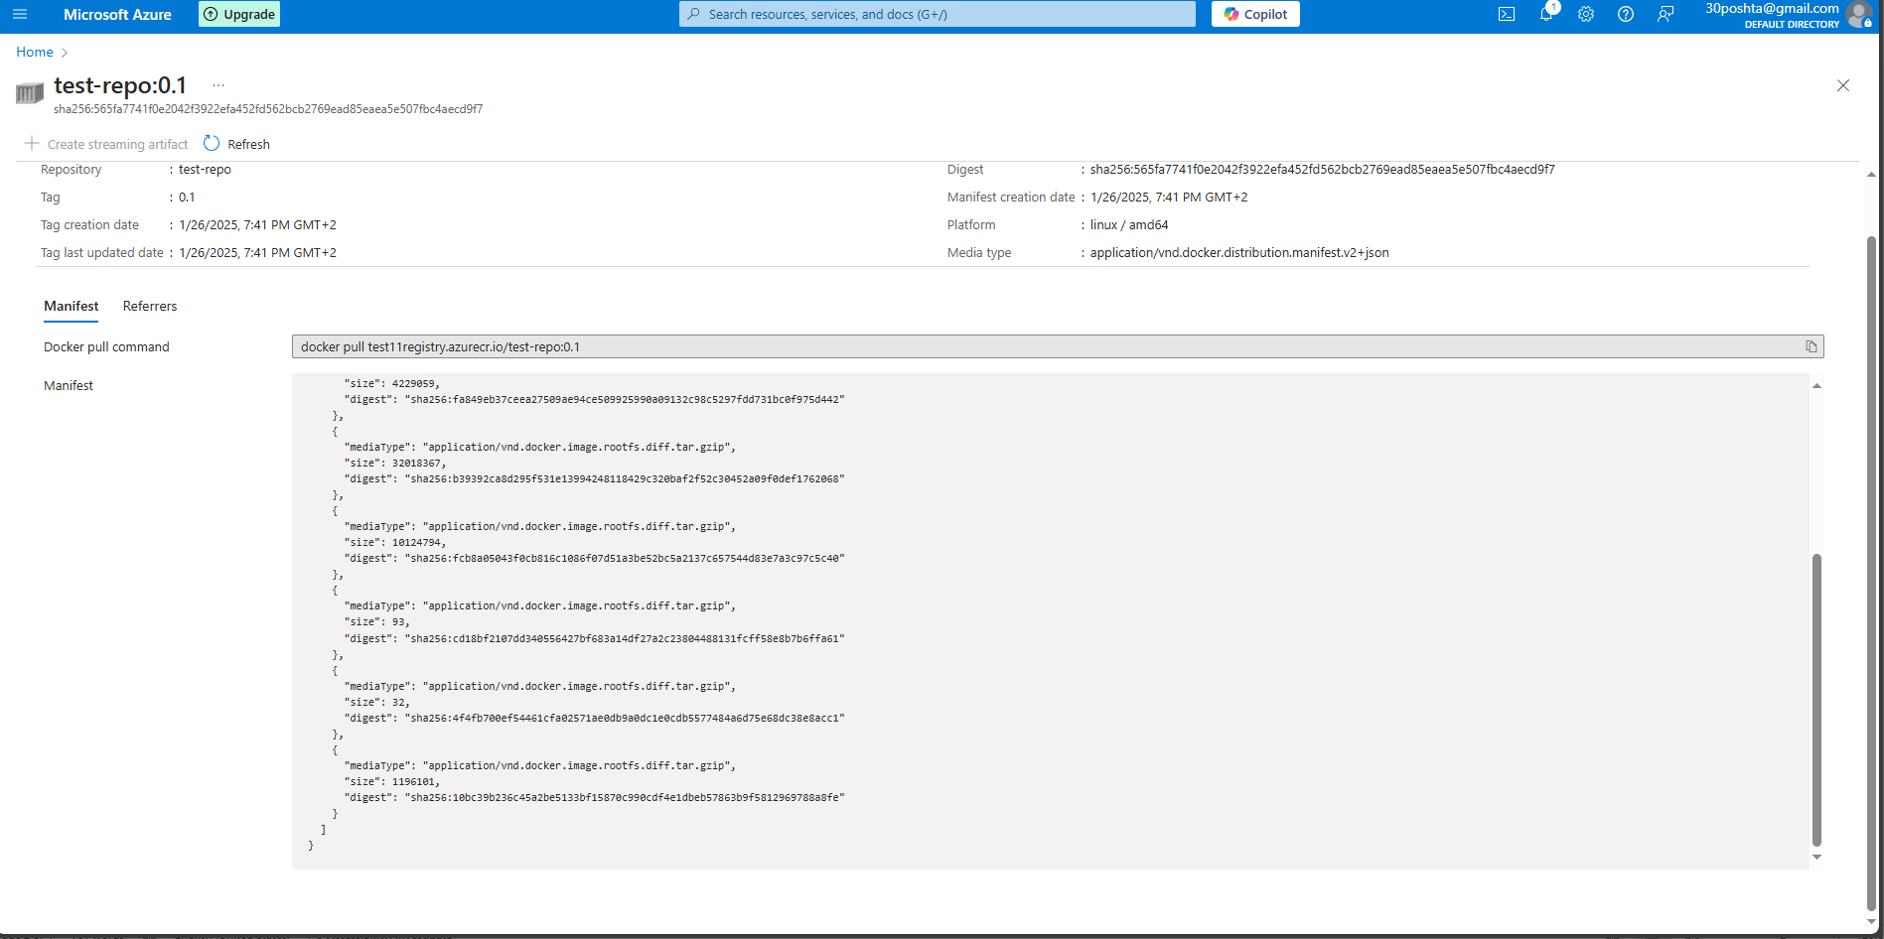

4. Verify the deployment by accessing the web application via the public IP address provided by ACI.

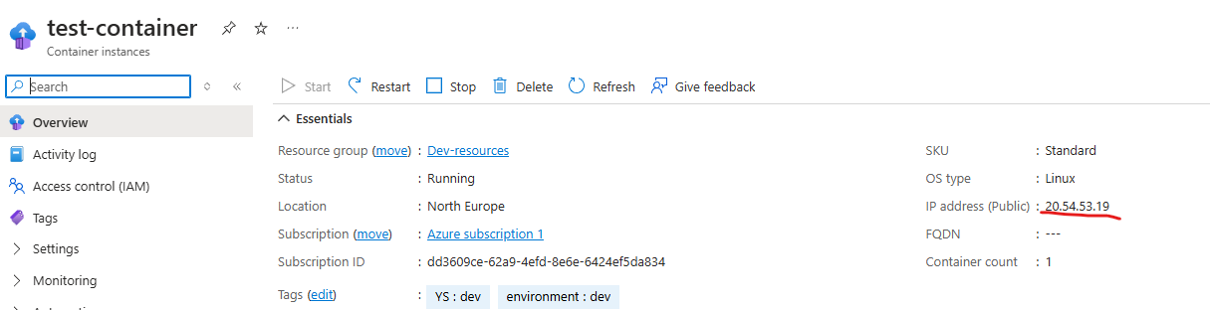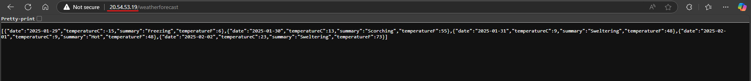

5. Remove the ACI container after verifying the deployment to stop billing.

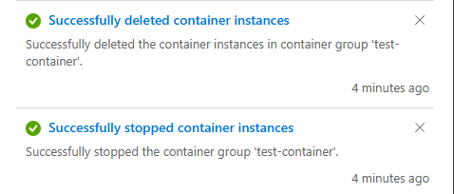

**Practical Task 2:** Configure Environment Variables in ACI via Azure Portal Requirements:

1. Modify your Docker image to read configuration values from environment variables, ensuring minimal environmental complexity. 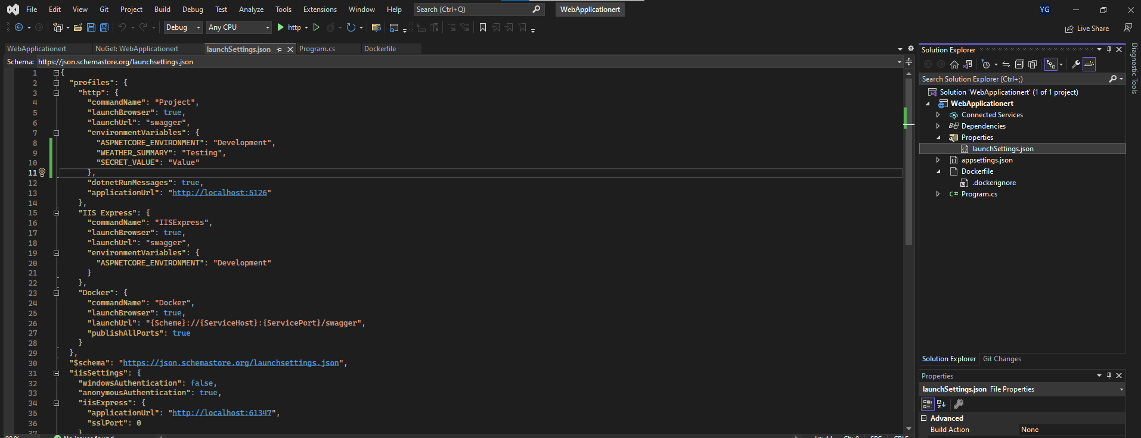

2. Reuse the ACI instance from Task 1 to deploy the container and specify the necessary environment variables. 

3. Verify that the application is correctly using the environment variables by checking its output. 

4. Remove the ACI container after verifying that the application correctly uses the environment variables. 

**Practical Task 3:** Scale Out with Azure Container Instances via Azure Portal Requirements:

Azure container instances do not scale, therefore I used azure container app

1. Deploy a stateless Docker container to Azure Container Instances using a lightweight configuration (e.g., B1s instances). 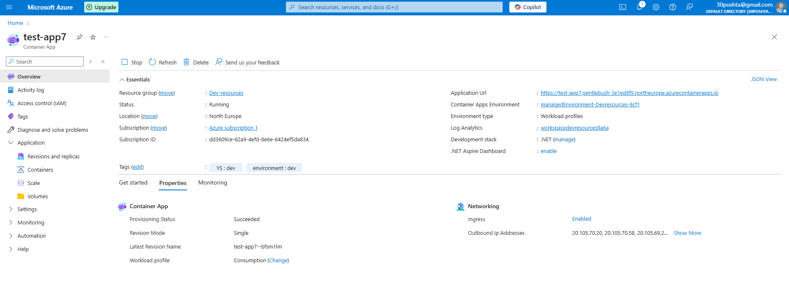

2. Manually scale out to the minimum number of instances required (e.g., 2–3) to test load distribution. 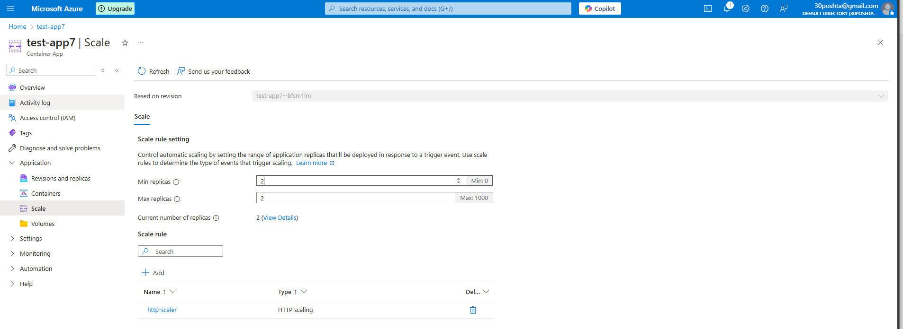

3. Stop all ACI instances after completing the testing to reduce ongoing costs. 

**Practical Task 4:** Secure a Docker Container in ACI with Managed Identity via Azure Portal Requirements:

1. Deploy a Docker container to Azure Container Instances using the existing lightweight ACI setup from previous tasks. 

2. Configure a Managed Identity for the ACI and securely access an Azure service (e.g., Azure Key Vault) with minimal permissions and access scope. 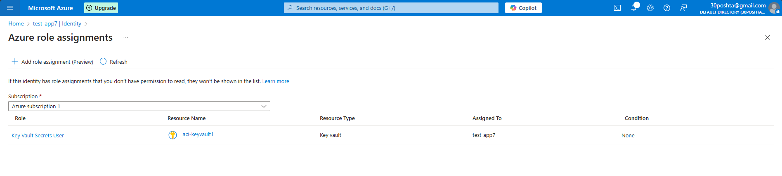

3. Retrieve only a single secret from Azure Key Vault for testing purposes.



4. Remove the ACI container after verifying secure access. 

**Practical Task 5:** Deploy a Kubernetes Cluster with AKS via Azure Portal Requirements:

1. Create an Azure Kubernetes Service (AKS) cluster with the smallest VM size (e.g., B2s) and the minimum number of nodes (e.g., 1–2). 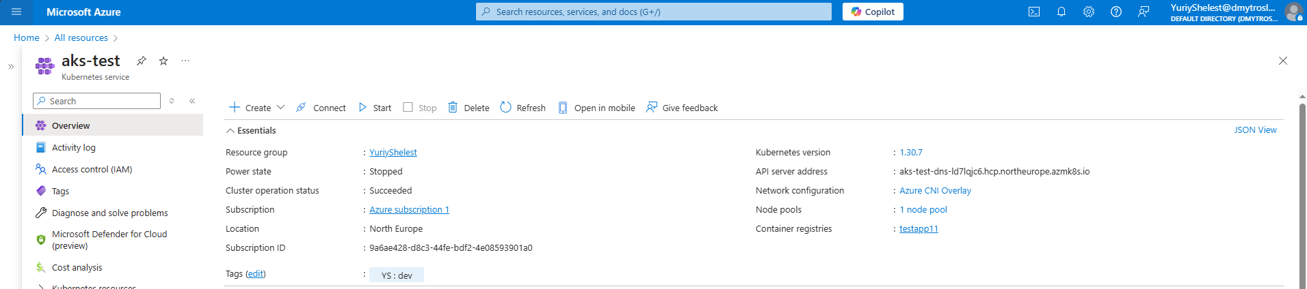

2. Connect to the AKS cluster using Azure Cloud Shell with kubectl. 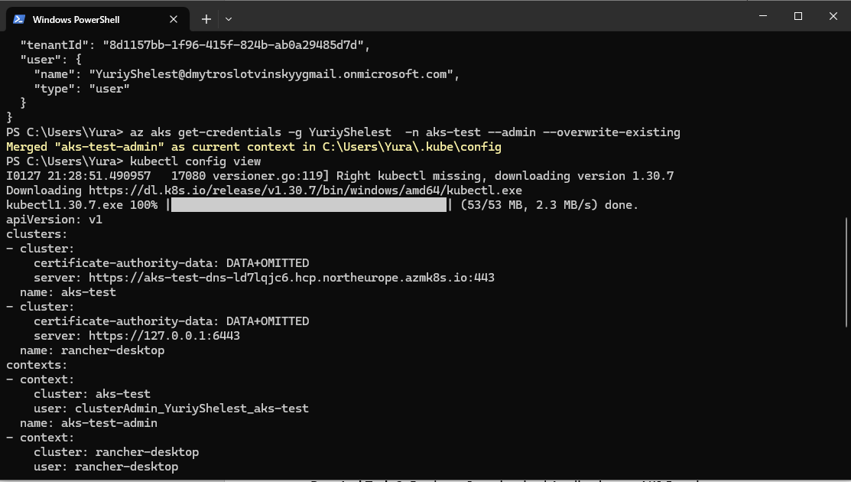

3. Deploy a lightweight Nginx application for verification. 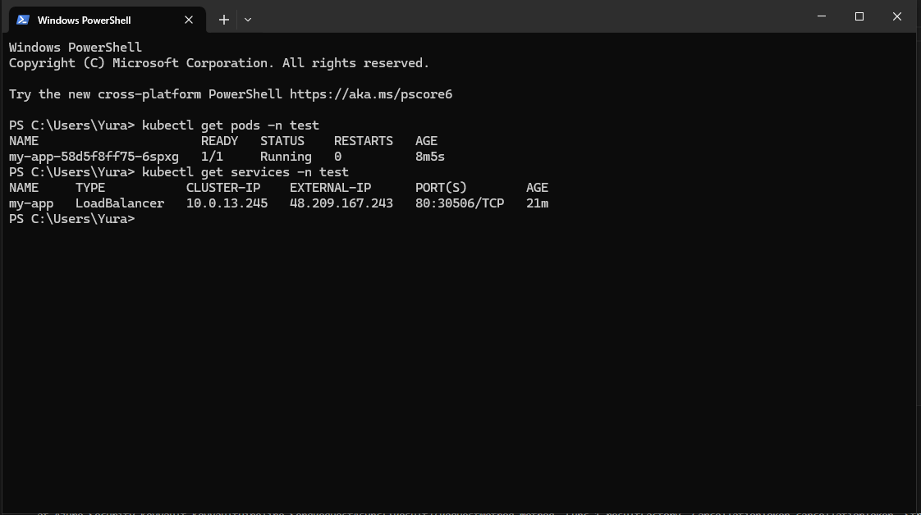

4. Delete the AKS cluster immediately after testing to avoid additional VM and cluster costs.

**Practical Task 6:** Deploy a Containerized Application on AKS Requirements:

1. Build a lightweight Docker image for a simple web application (e.g., a Node.js app with minimal dependencies) and push it to Azure Container Registry (ACR).

USING SAME APP EVERYWHERE

2. Reuse the AKS cluster from Task 5 to deploy the application using a Kubernetes deployment and service manifest file. 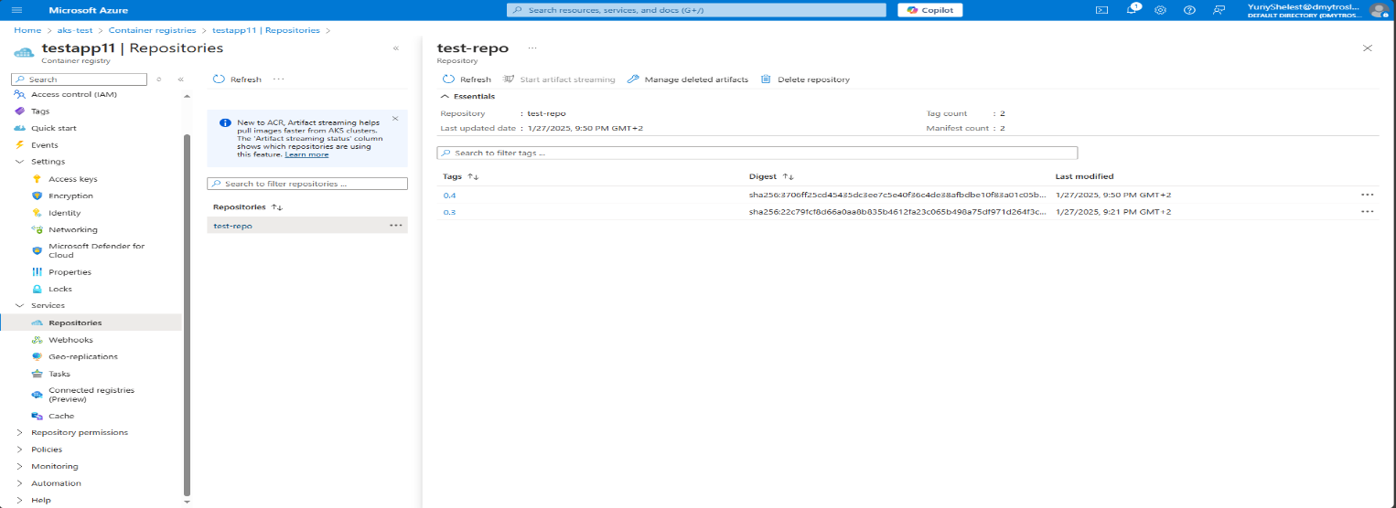 will be added to the repo

3. Test the application for a limited time and remove the deployment afterward. 

**Practical Task 7:** Configure and Use ConfigMaps and Secrets in AKS Requirements:

1. Create a ConfigMap to store non-sensitive configuration data with only the required keyvalue pairs for the application. 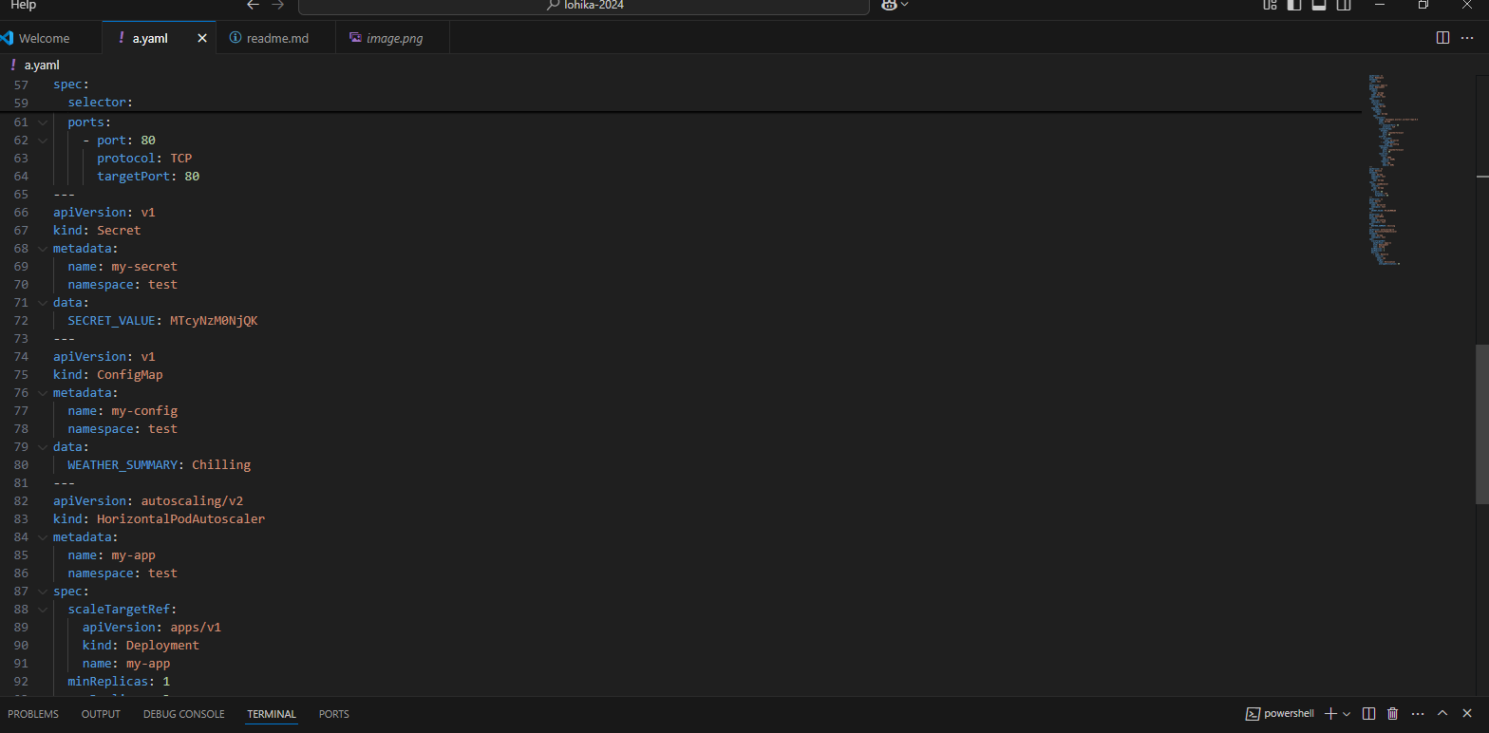

2. Create a Kubernetes Secret to store sensitive data (e.g., API keys) with the least amount of information needed. 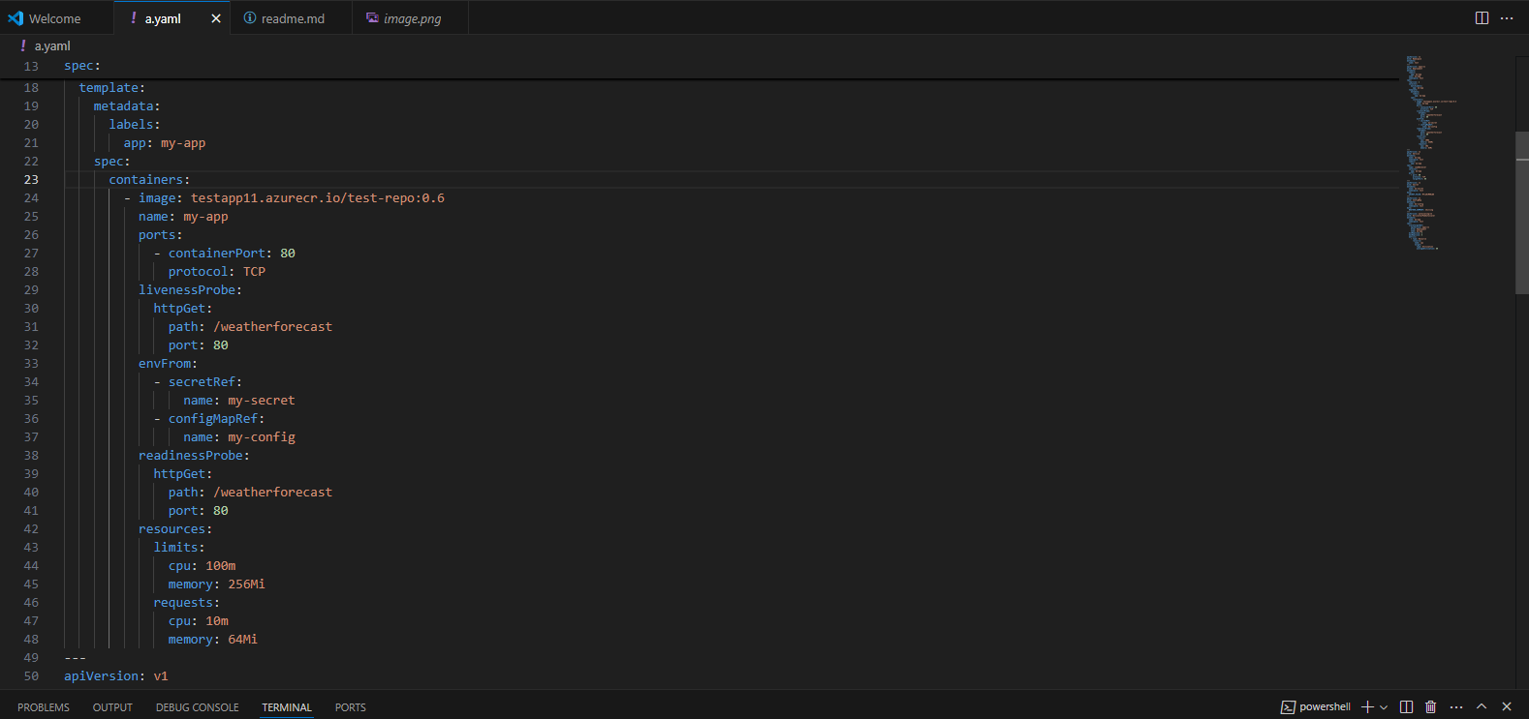

3. Update the application deployment to use the ConfigMap and Secret. 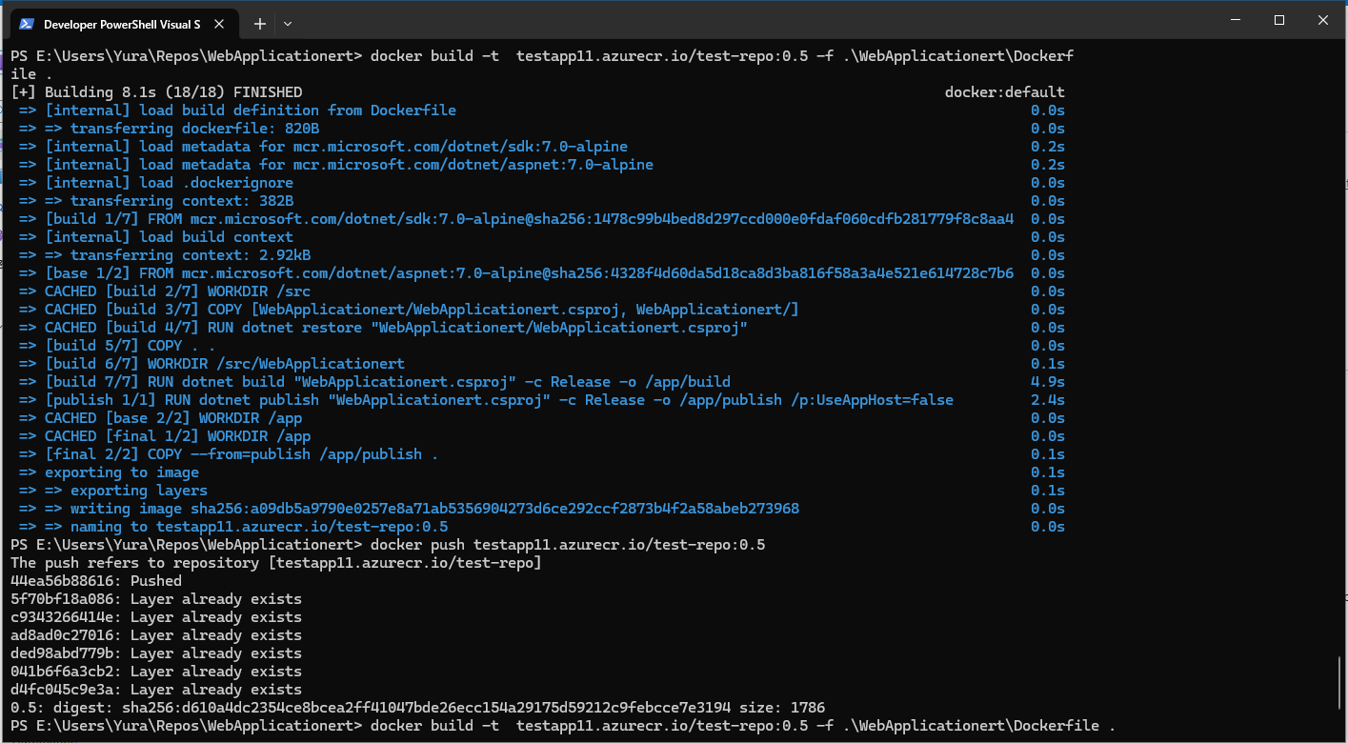

4. Remove the ConfigMap, Secret, and deployment after testing.

**Practical Task 8:** Scale Applications in AKS Requirements:

1. Deploy a stateless application to the AKS cluster using minimal resource specifications.

USING SAME APP EVERYWHERE

2. Use the kubectl scale command to manually scale the application to only 2–3 replicas for testing. 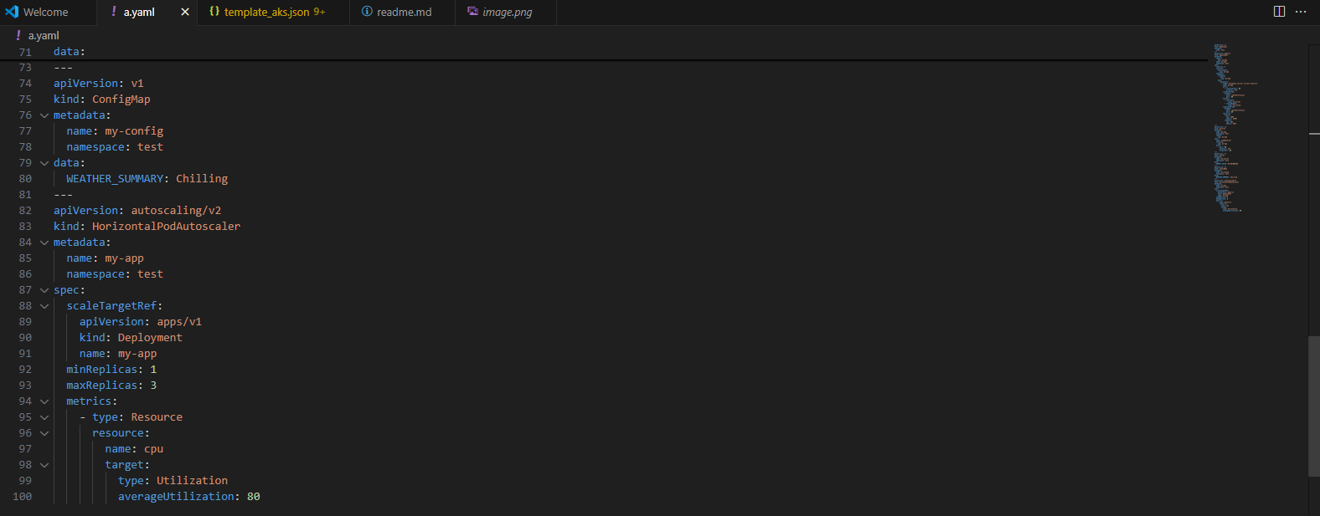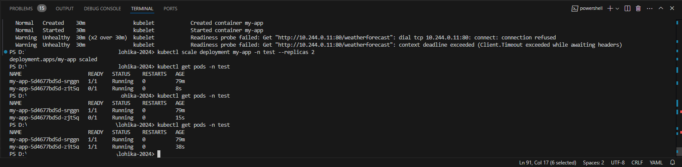

3. Set up Horizontal Pod Autoscaler (HPA) with reasonable CPU usage thresholds to minimize pod creation. 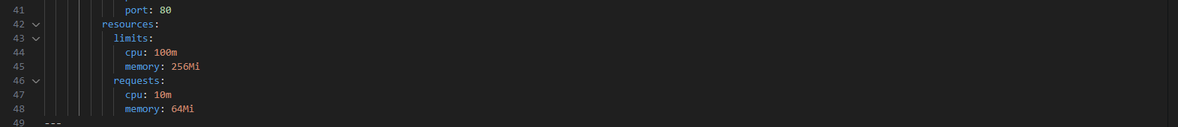

4. Simulate load on the application for a short duration and remove the deployment after observing the scaling behavior. 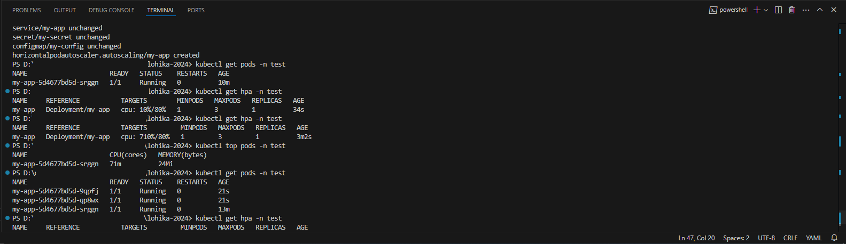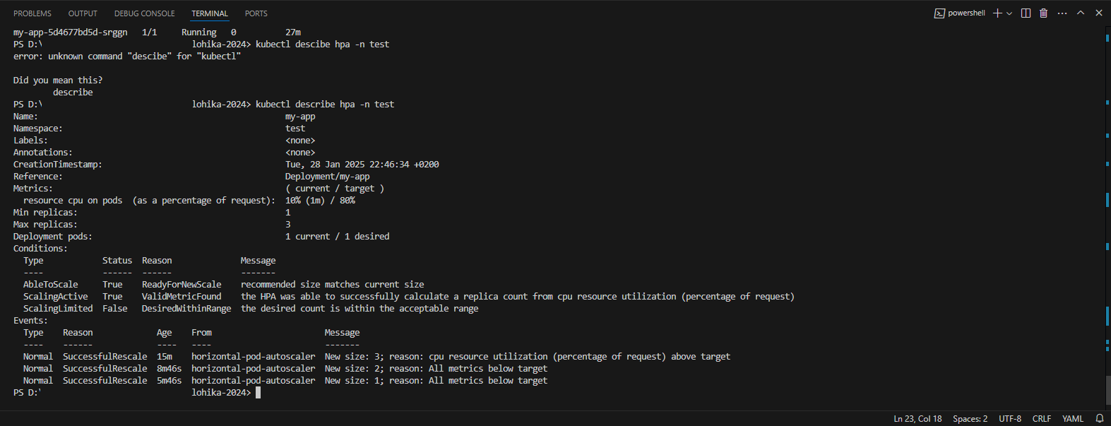

More scaling in task 10

**Practical Task 9:** Rolling Update of an Application in AKS Requirements:

1. Deploy a lightweight version of your application to the AKS cluster. 

USING SAME APP EVERYWHERE

2. Update the Docker image to a new version with minimal changes (e.g., color change). 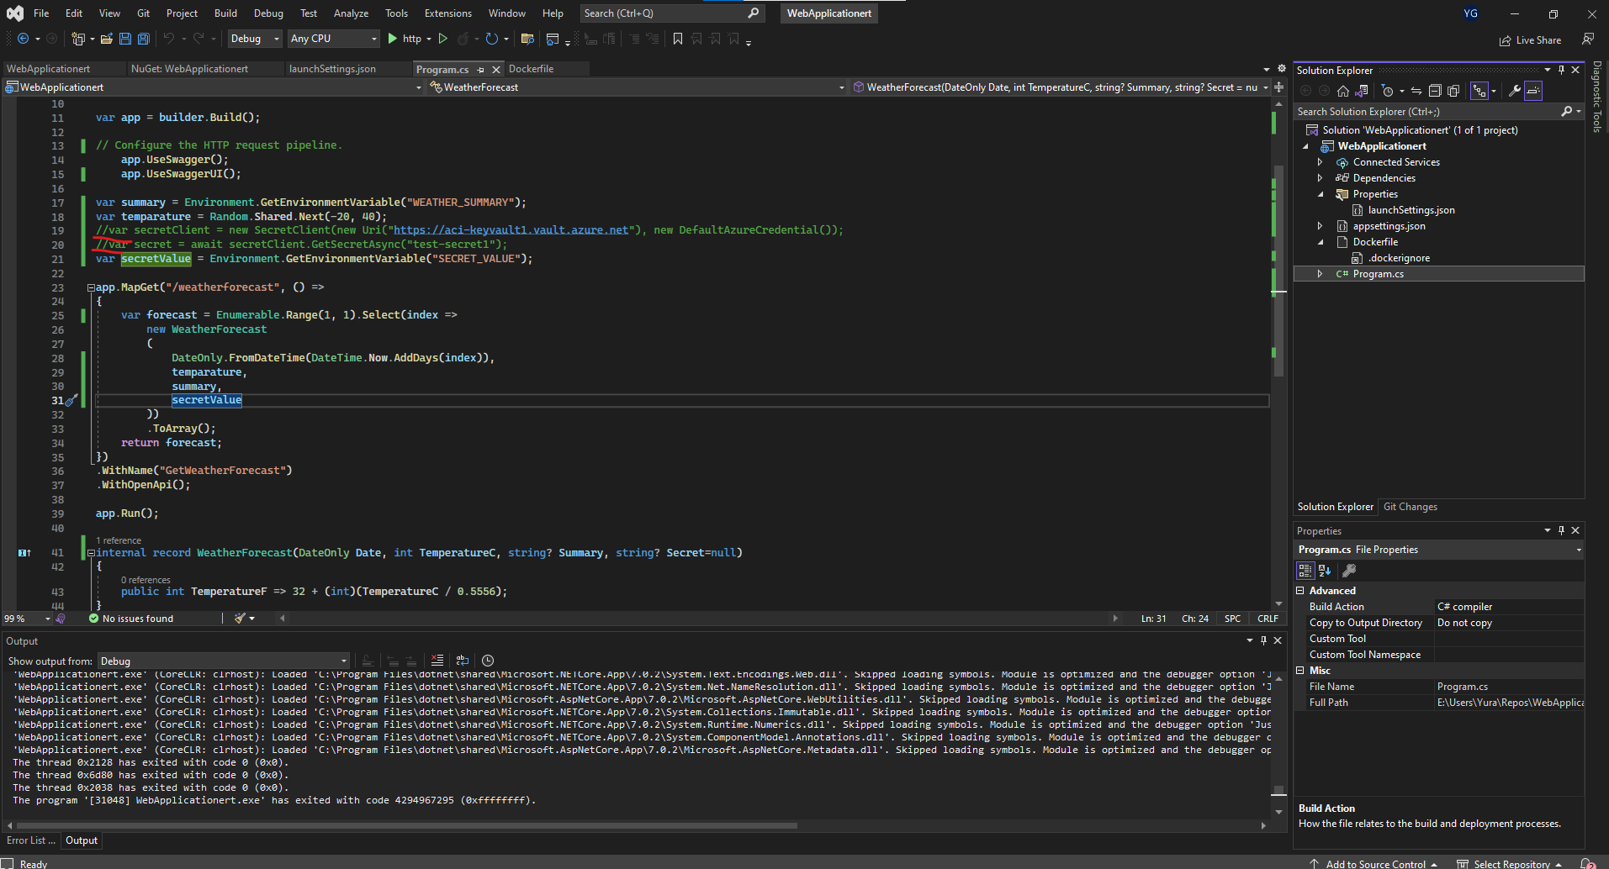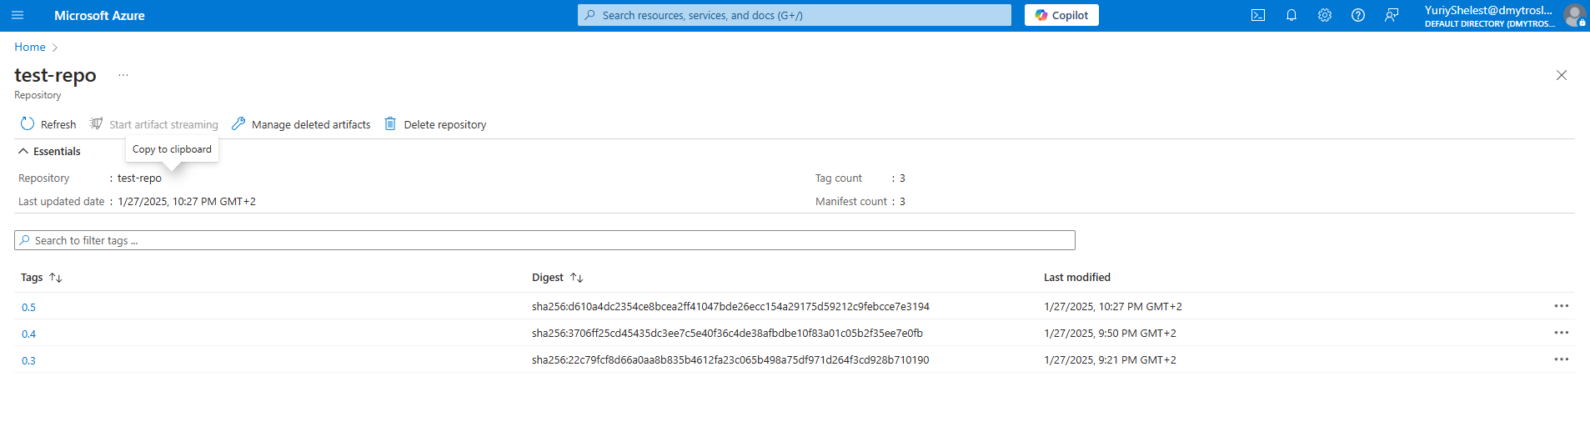

3. Perform a rolling update using kubectl set image with minimal replicas to reduce resource usage.



4. Verify the update process quickly and remove the deployment after the update.



**Bonus task.** GitOps with AKS Requirements:

1. Setup ArgoCD on Azure Kubernetes Services 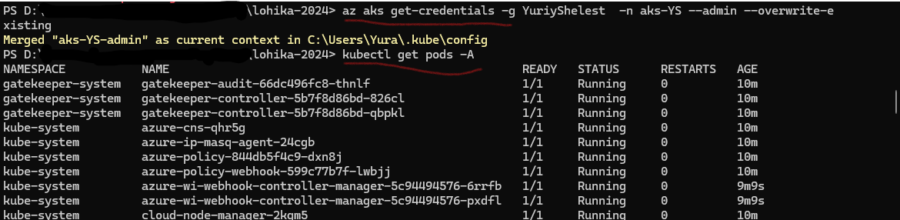

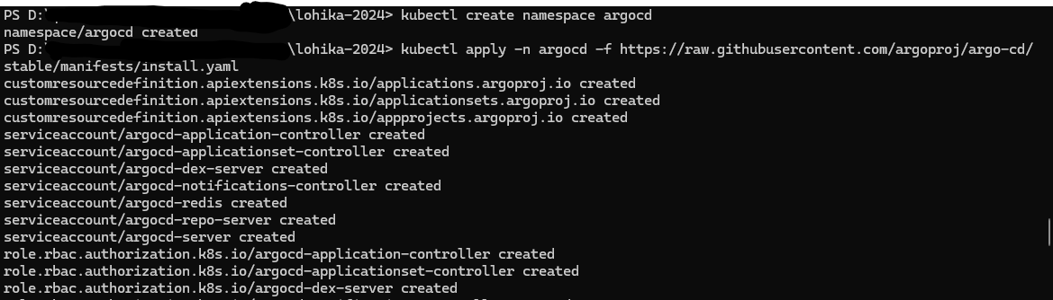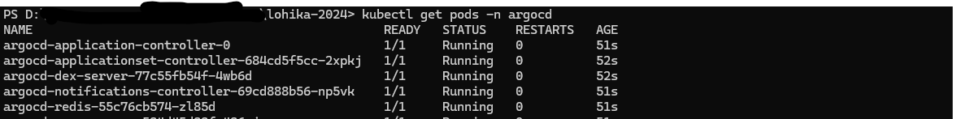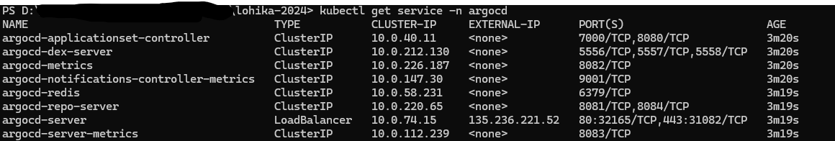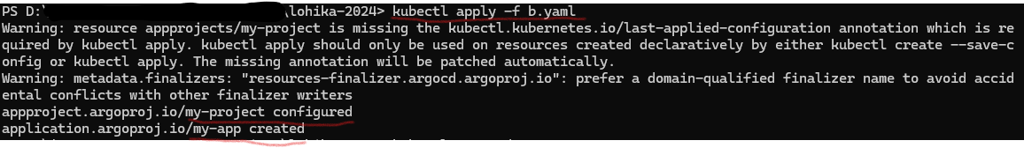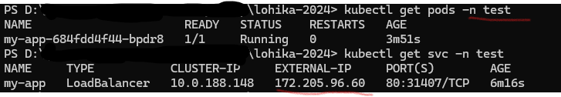

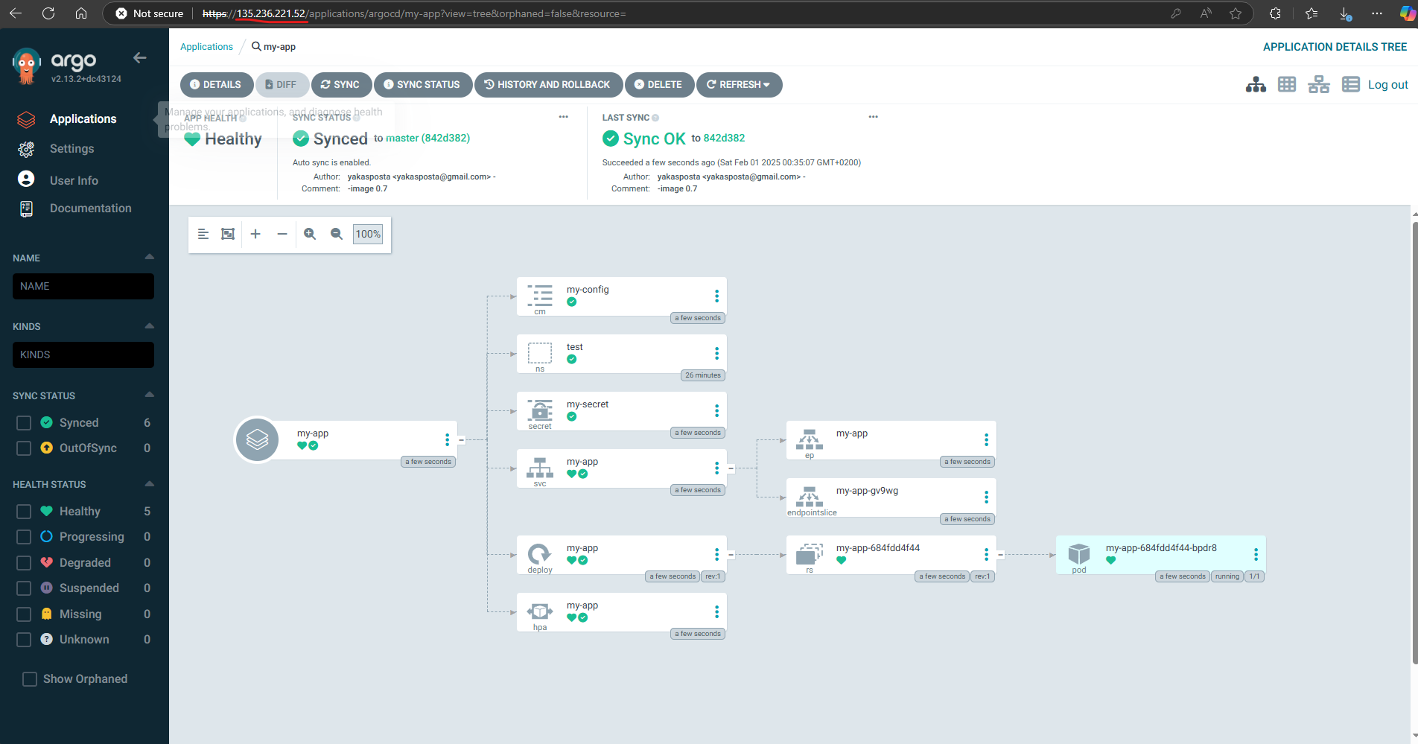

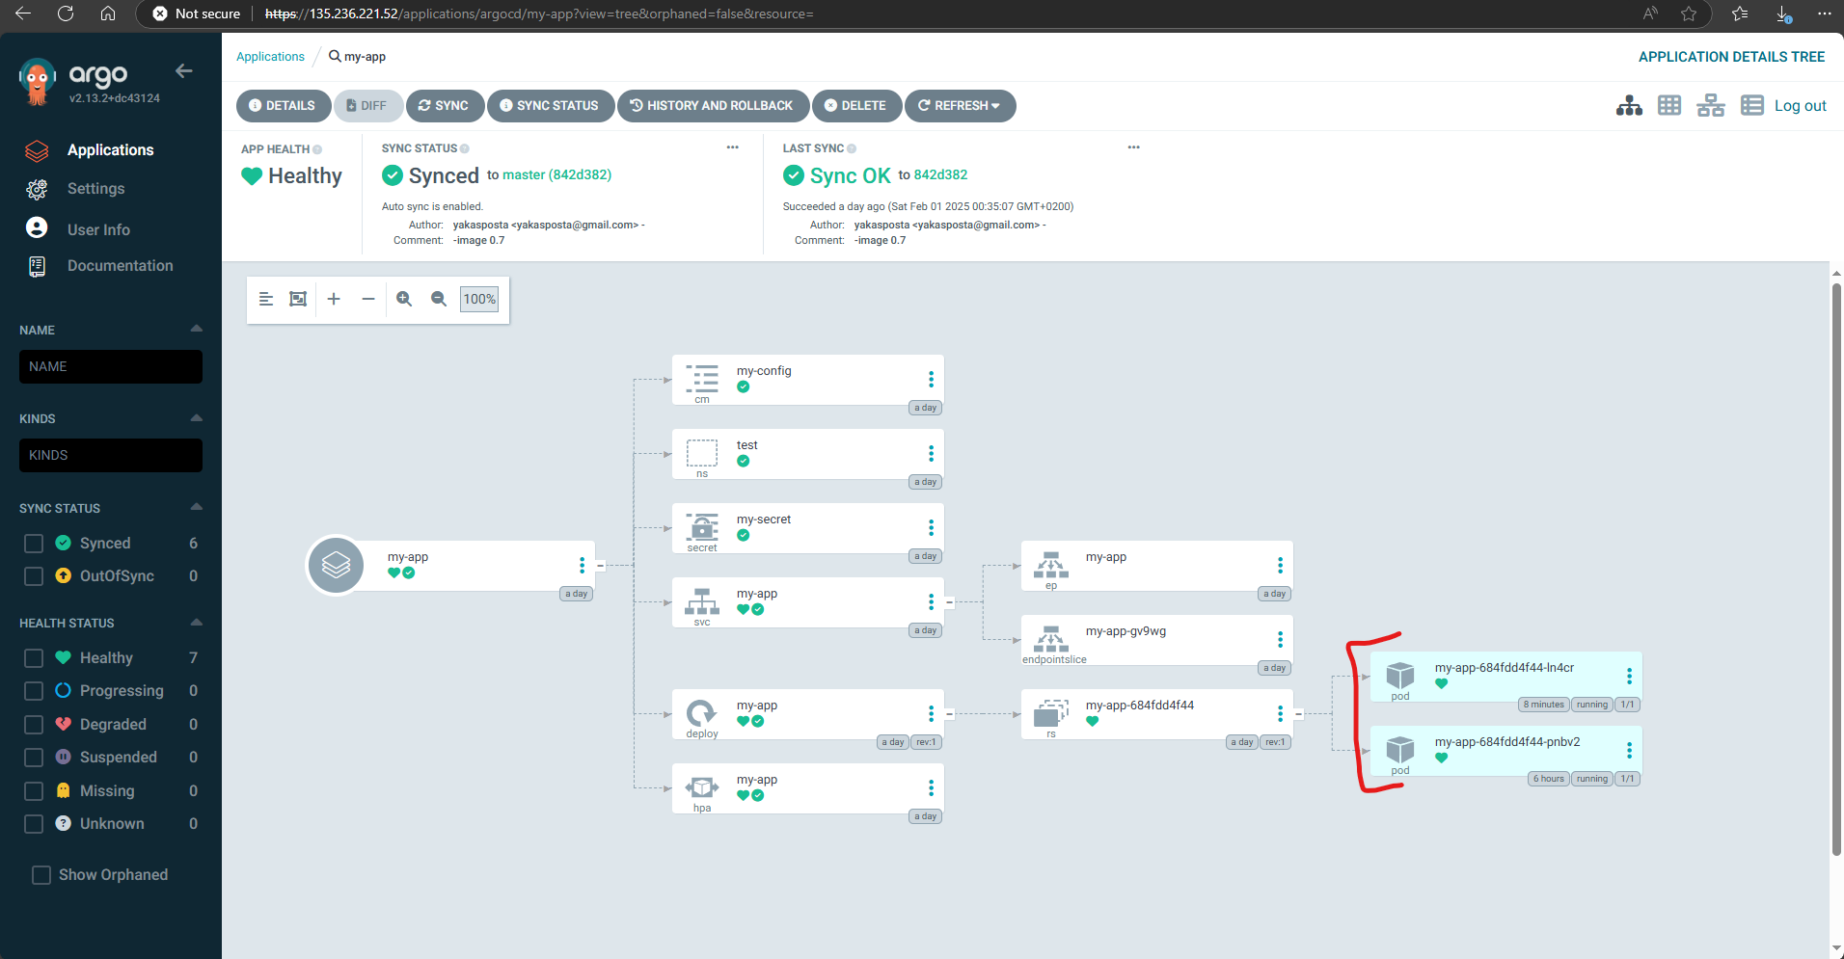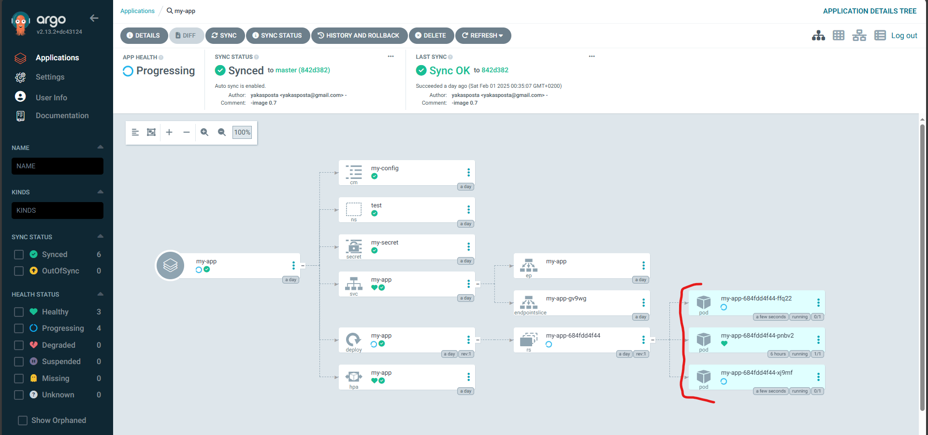





2. Perform image update on cluster 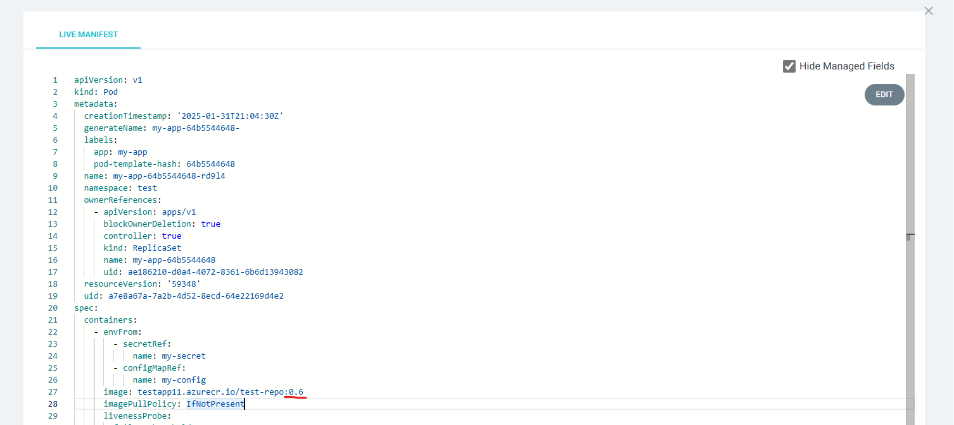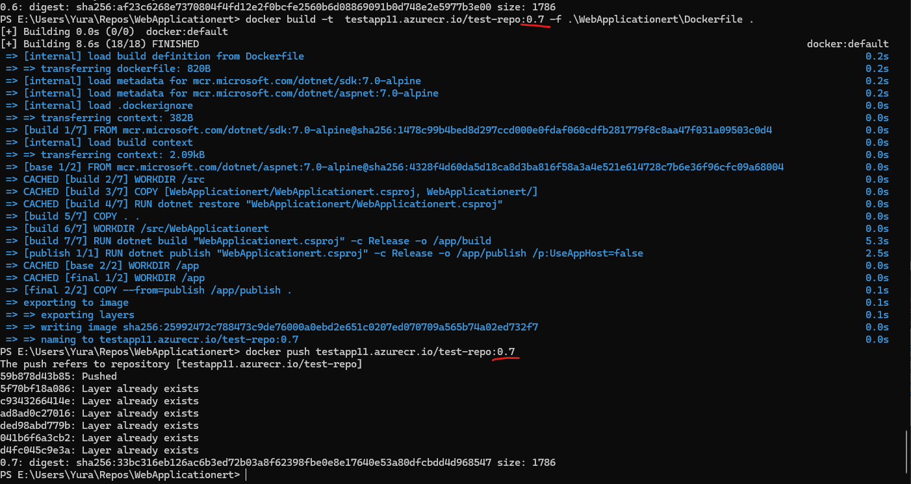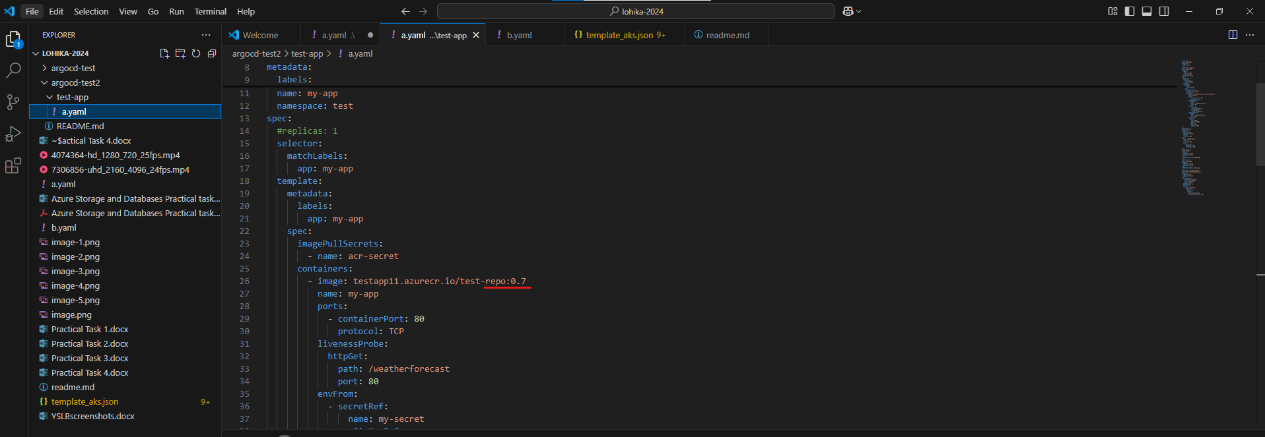

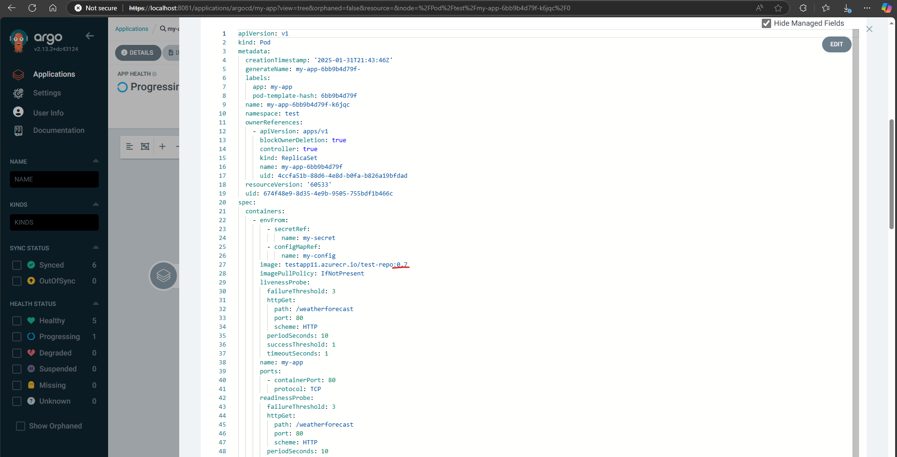

**Source:**

<https://foxutech.medium.com/setup-argocd-on-azure-kubernetes-services-9c3fa543f4b6>

https://learn.microsoft.com/en-us/azure/architecture/example-scenario/gitops-aks/gitopsblueprint-aks

https://araji.medium.com/embracing-gitops-setting-up-a-gitops-ready-cluster-on-azure-with-aksargocd-and-terraform-0fd6f9121088

